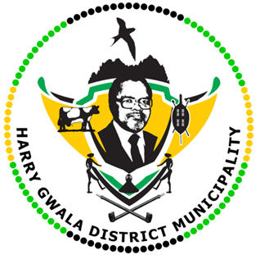
HARRY GWALA DISTRICT MUNICIPALITY
“Together We Deliver and Grow”
OFFICE OF THE MUNICIPAL MANAGER
40 Main Street, Private Bag X501, IXOPO 3276
Tel: (039) 834 8707 Fax: (039) 834 1701
Email: NgubaneN1@harrygwaladm.gov.za

17 JULY 2023

The Harry Gwala District Netball, the winning team.

His Worship the Mayor of the Harry Gwala District Municipality, Cllr ZD Nxumalo, congratulates the Harry Gwala Under 19 Netball team for being crowned the 2023 Telkom Netball Junior Champions.
The team traveled to Cape Town to participate against 14 teams. The games were held at DF Malan High School in Belville, Cape Town, featuring the country’s U17, U18 and U19 teams. The games commenced on the 10th of July 2023 until 14th of July 2023.The Harry Gwala team played the finals against Ekurhuleni and won 51-22.
The girls won all their games to become the 2023 u19 Championships.
Mayor Nxumalo said these girls are the future of Netball and congratulated the Netball Federation in the District.
“As the District we would like to congratulate the Harry Gwala Netball under 19 for being crowned champions. These young ladies are the future of Netball. We encourage them to continue working hard and one day we hope to see them represent the National team. We also congratulate their coach, the Netball Federation in the district, and all who are involved in making sure that Netball in the district grows, “said Mayor Nxumalo.
Mayor Nxumalo said the Under 19 team should be motivated by Refiloe ‘Fifie’ Nkentsa from Shayamoya in Kokstad, who is one of the players representing the South African National team (Proteas) in the upcoming Netball World Cup which will be in Cape Town.
The Under 19 team received gold medals for being champions and one player was invited to trials for the Under 19 S.A Team.
The Harry Gwala Netball Federation Chairperson Ms. Nonhle Nkomo said she is proud of the team and thanked the municipality for the support.
“It was a great opportunity for under 19 girls to show their talent and to be exposed in high performance. On behalf of Harry Gwala Netball, I would like to thank our District Municipality with transport support for all our events could be super league/championships, we are grateful. To Harry Gwala DSAC who supported us with the accommodation of high standards. without our stakeholders we are nothing. Once again congratulations to the coach Berto Mnikina and the girls, we are very proud of them and happy that they are flying our Harry Gwala District flag high,” said Ms. Nkomo.
The Netball World Cup 2023 in Cape Town, South Africa will run from the 28th of July to the 6th of August, and will be the first to take place on the continent on Africa. 16 teams will be battling it out across the 10 days, in the hope they will be crowned champions in netball’s most prestigious event.
ISSUED BY HARRY GWALA DISTRICT MUNICIPALITY COMMUNICATIONS UNIT.
0398348707

